FIELD REPORT

Introduction
Lakwana Seed Secondary School
Location: Omoro district
Date of visit: 2nd September 2026
- General observations
- Engraving was observed on the desks; however, the engraving was not properly done. The code “LAKWANA SEED SECONDARY SCHOOL” was used, while the other furniture, including chairs, had no visible engraving.
- The ICT/Library block was accessible for verification, but its plywood ceiling was in poor condition and appeared to be deteriorating, with sections almost falling off. The ceiling requires renovation to ensure the safety and usability of the block.
- A limited number of ICT equipment was supplied to the school. These included 28 desktop computers, 28 CPUs, 10 extension cables and 1 CCTV camera. Other equipment indicated as required, such as routers and projectors, had not been supplied.
- The school currently relies on ICT equipment supplied through the UCC program for connectivity, as some of the expected UGIFT ICT infrastructure, particularly routers, was not available on site.
- Science laboratory reagents and apparatus were not available at the school, despite appearing on the delivery documentation. The school has been purchasing the required laboratory supplies using its own resources to support practical lessons. Gas cylinders, gas taps, and bunsen burners were reported/indicated as supplied yet not supplied.
- Some buildings showed signs of deteriorating paint, including the pit latrines serving the staff quarters. Repainting and general maintenance are required to improve the condition of the facilities.
- Desks for one classroom block were not supplied. The block is currently being used as a girls' dormitory, meaning the intended classroom space is being utilized for accommodation and remains without the expected desks.

Asset verifications and documentation
- The school did not have copies of the delivery notes or other records showing the items that were delivered under UGIFT. The head teacher reported that several requests had been made to the district to provide the relevant documentation, but the records had not yet been availed.
- The absence of delivery documentation limited the school's ability to clearly account for the assets supplied under UGIFT and made it difficult to reconcile the items physically available at the school with the quantities and specifications expected under the program as well as distinguish between assets supplied under UGIFT and those subsequently provided through other programs, such as UCC.
- There were also differences between the items indicated in the available delivery information and what was observed on the ground. In particular, some ICT equipment, such as routers and projectors, was not available, while science laboratory reagents and apparatus were also not available despite being indicated in the delivery documentation.

Special notes
- The school has made efforts to address some of the gaps in the supplied laboratory equipment by purchasing reagents and apparatus using its own resources, enabling science practical activities to continue despite the reported shortfall.
- Reliance on UCC-supplied ICT equipment for connectivity indicates that the school has sought alternative support to meet its ICT and connectivity needs where the expected equipment was not available.
- The condition of the ICT/Library block ceiling requires attention, as further deterioration could affect the safety of learners and staff and potentially expose ICT equipment to damage.
- The use of a classroom block as a girls' dormitory, coupled with the absence of desks, represents a space-utilization challenge that may affect the availability of adequate classroom facilities.

The table below illustrates some physical status of the verified assets with photographic evidence.

Table XXX: Physical verification photos

SCIENCE LABOLATORY BLOCK WITH TWO UNITS | 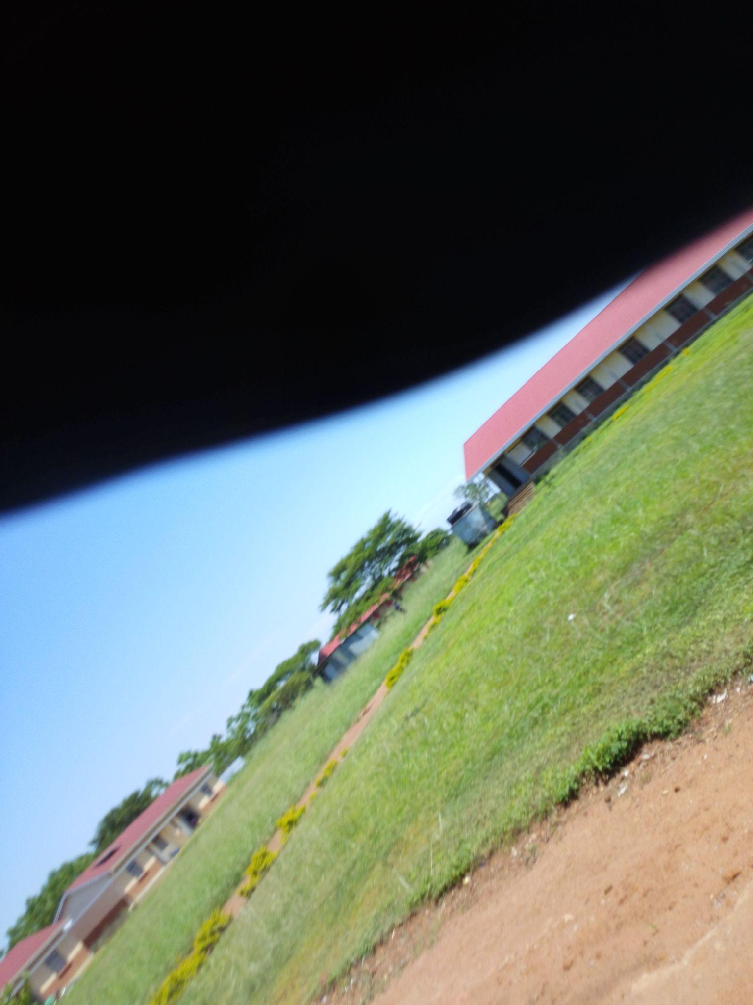
10,000 LTRS HDPE CREST TANK | 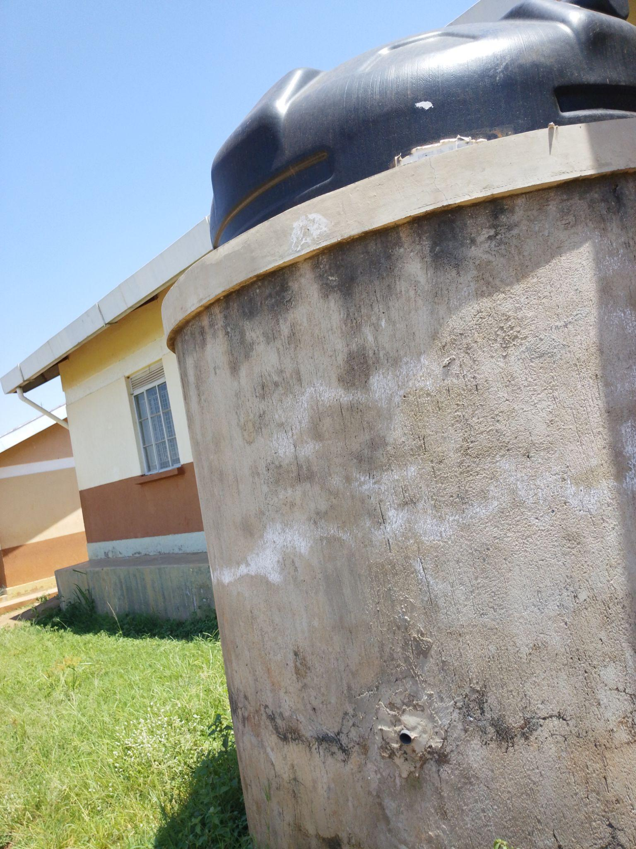
TYPICAL TWO-UNIT CLASSROOM BLOCK | 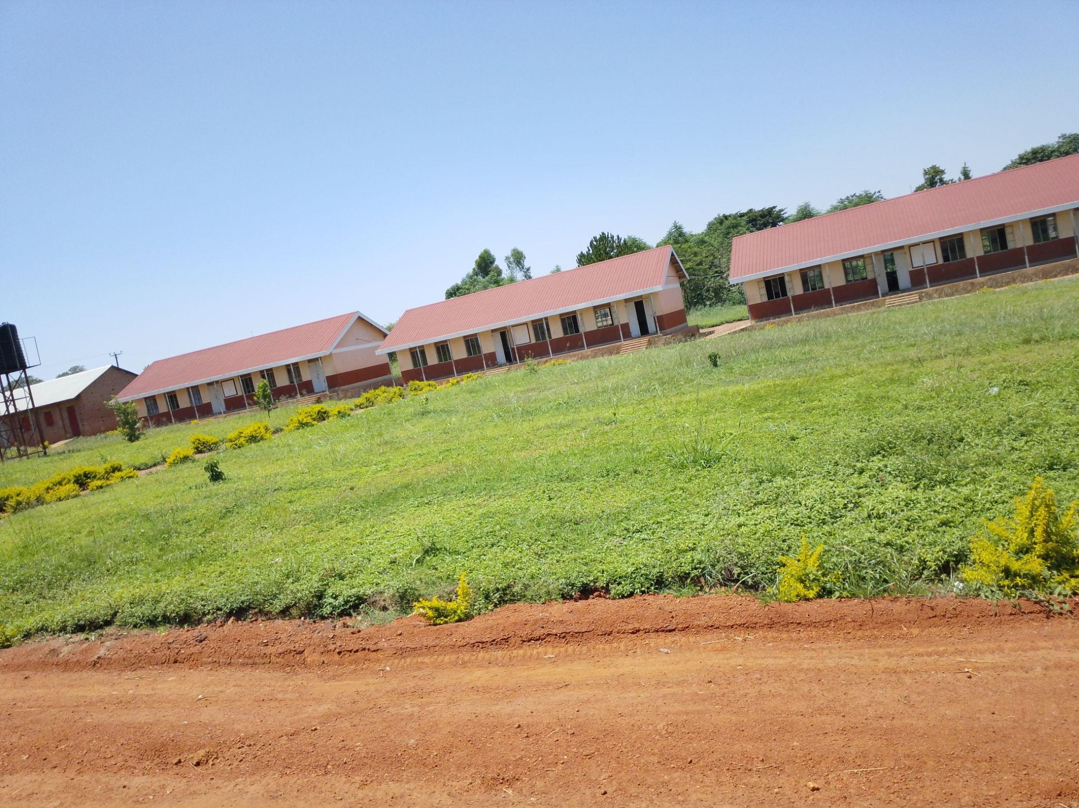
TYPICAL 5-STANCE VIP PIT LATRINE BLOCK | 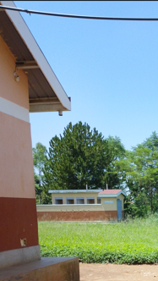
COMPUTER SET (MONITOR, UPS, POWER) | 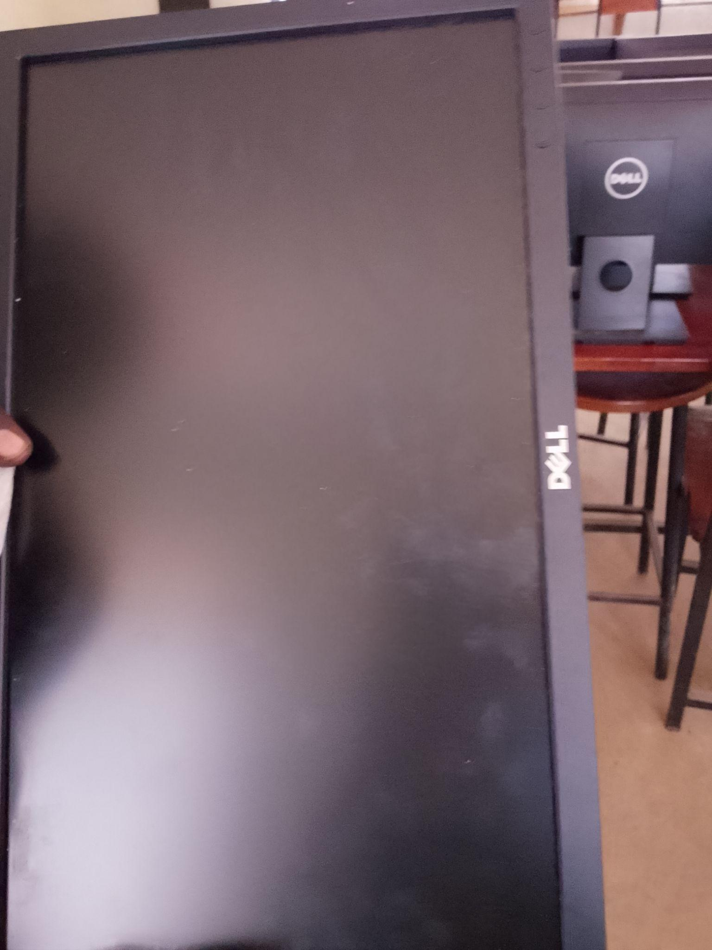
WALL LABORATORY TABLE WITH SHUTTERS AND SINKS AND WATER CONNECTION | 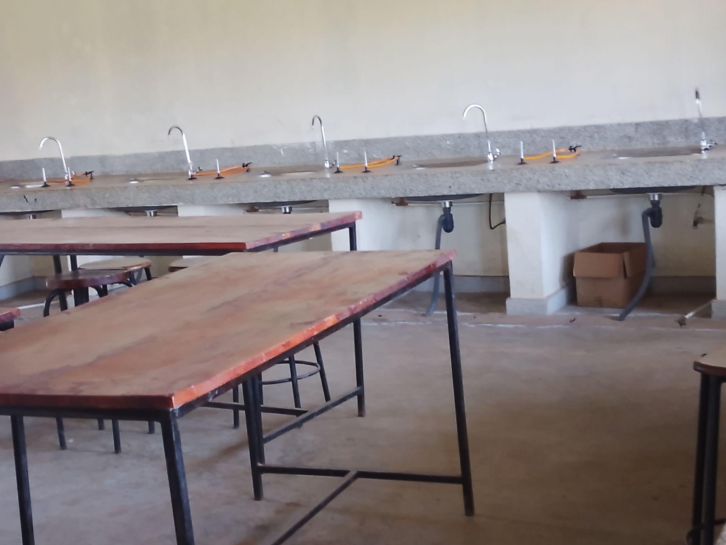
SAMPLE OF LABORATORY STOOLS AND ONE OF THE DAMAGED STOOLS | 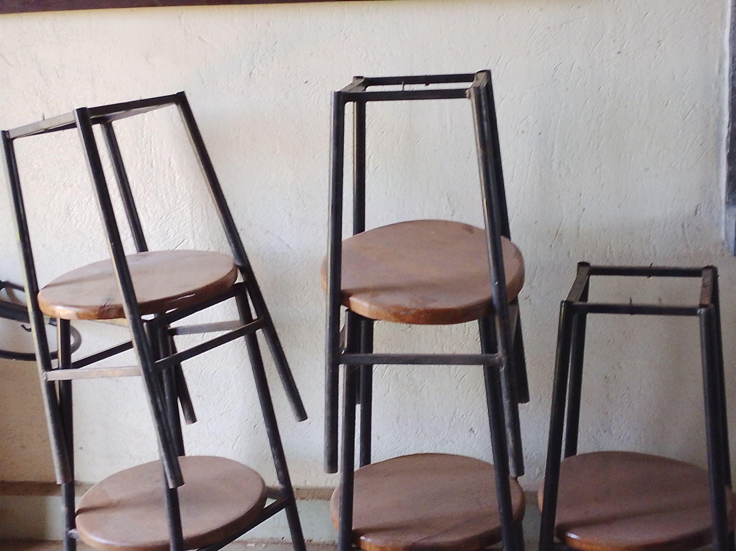  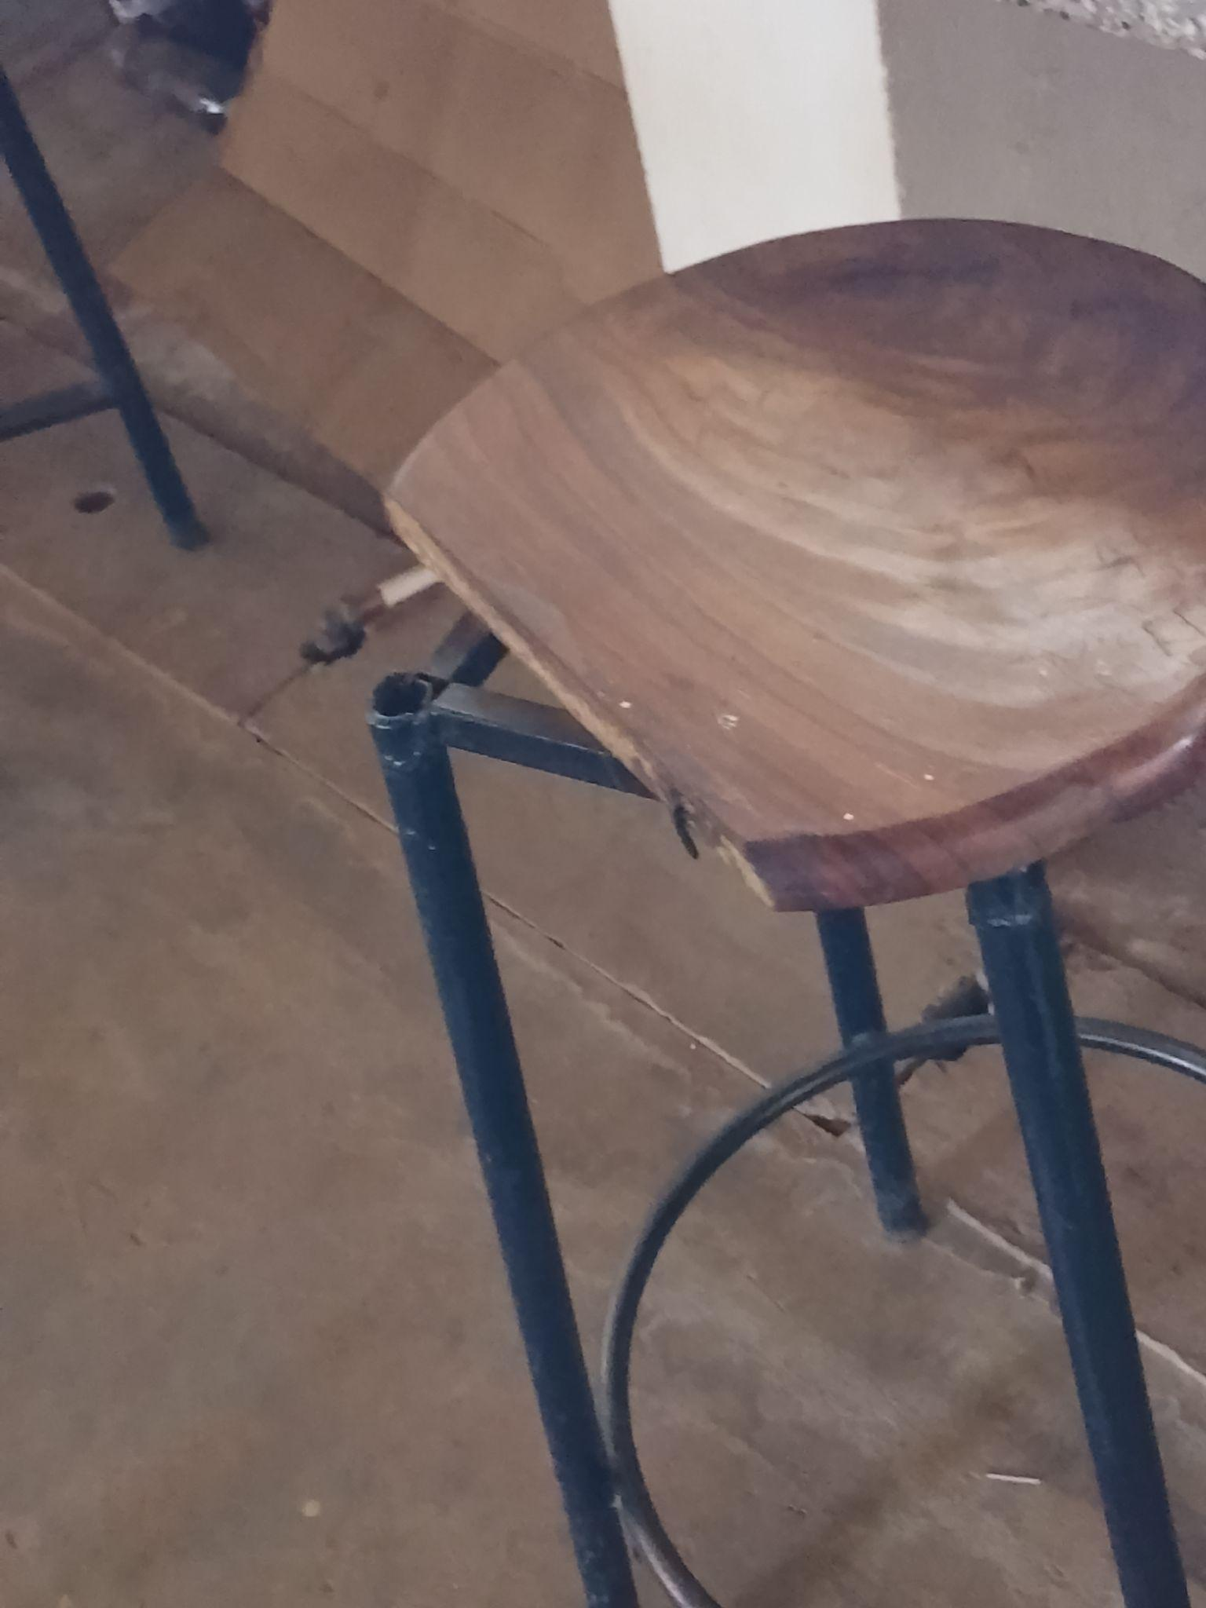
SAMPLE OF desks, ENGRAVED | 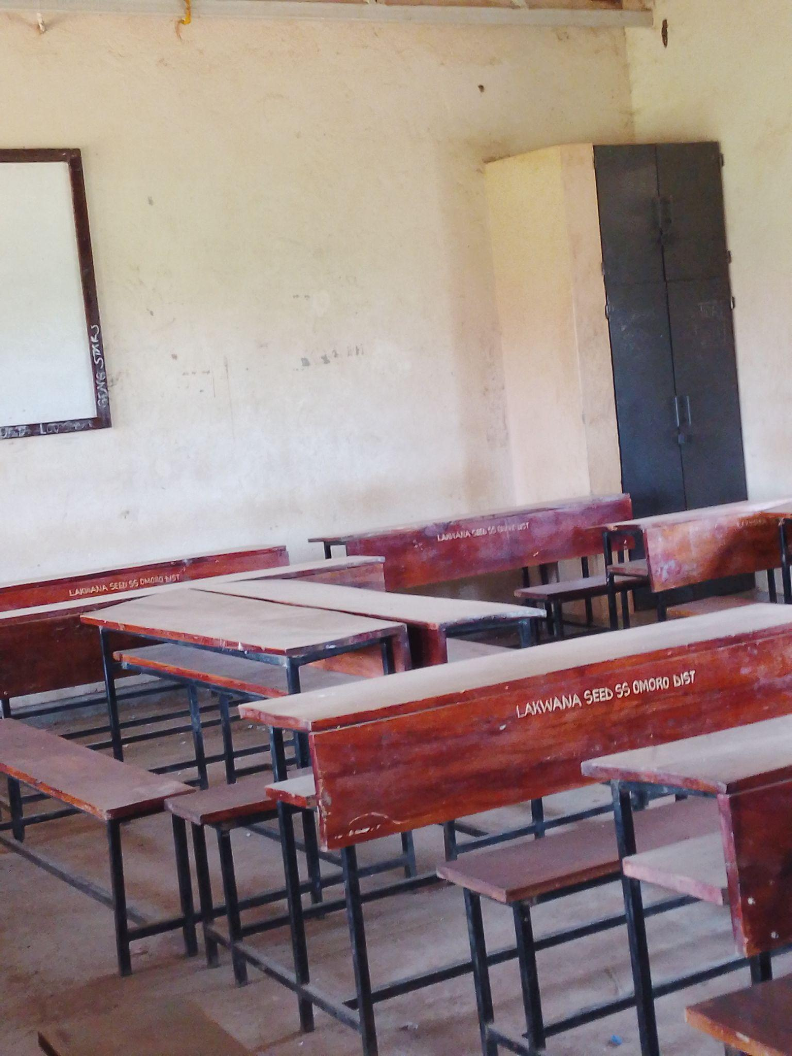
CHAIRS AND INTERIOR OF THE COMPUTER LABORATORY | 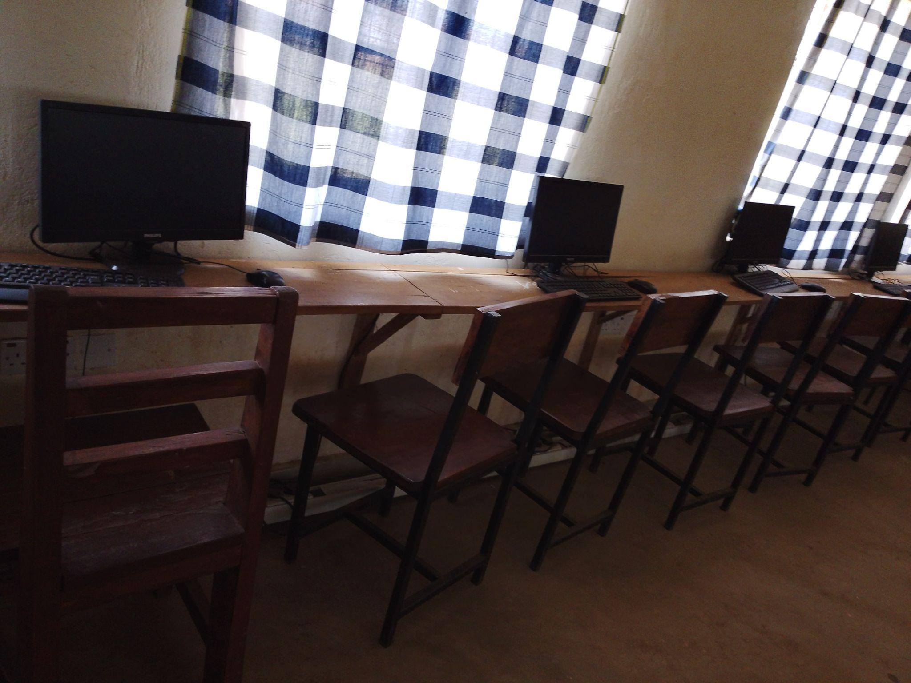
LIBRARY BOOK SHELVES, TABLES AND CHAIRS | 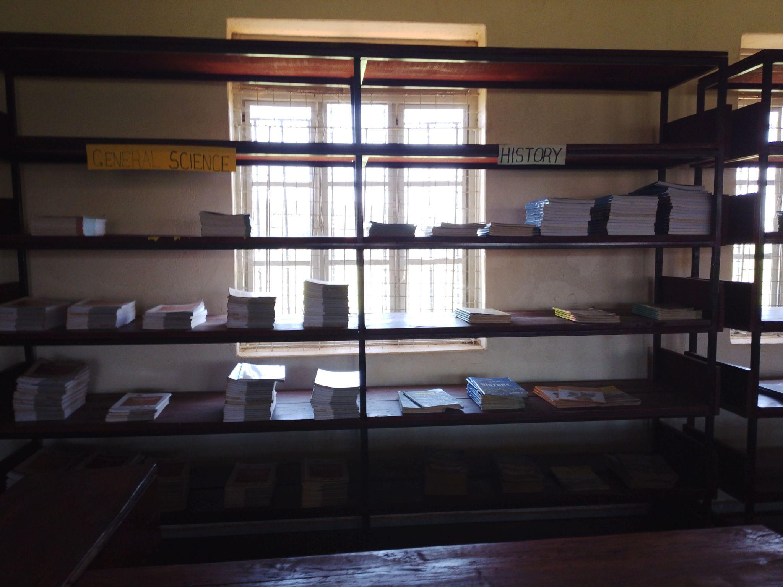
STAFF TOILETS | 